

**SCIENCE**

**EARTH & SPACE**

**MODULE 1: MAGNETISM**

**Introductory Message**

A self-learning module is prepared to help you study and understand new topics on your own, without needing a teacher to guide you at every step. It allows you to learn at your own pace and in a way that works best for you.

The module provides clear instructions, examples, and exercises that you can work through by yourself.

Use this module carefully and don’t make any unnecessary marks on it. Write your answers to the exercises and tests on a separate sheet of paper. Make sure to read the instructions carefully before doing each task.

If you have any questions about using this module or having trouble with the tasks, feel free to ask your teacher or facilitator for help.

Thank you.



***What I Need to Know***

This module was created with you in mind to help you learn magnetism, types of magnets, the North and Sout Pole, and the everyday uses of magnets. It is designed to be used in different learning situations and uses language that suits various student vocabulary levels. The lessons follow the standard course sequence, but you can read them in any order that works best for you, similar to the textbook you are currently using.

The module is divided into four lessons, namely:

• Lesson 1 – Magnetism

• Lesson 2 – Types of Magnets

• Lesson 3 – North and South Pole

• Lesson 4 – Everyday Uses of Magnets

After going through this module, you are expected to be able to:

1. Define magnetism and identify different types of magnets.

2. Differentiate magnetic and non-magnetic materials.

3. Explain how magnets work and their role in the real world scenarios.

4. Apply knowledge of magnetism in real-life situations.

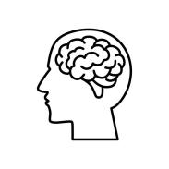

***What I Know (Pre Test)***

Directions: Choose the letter of the best answer. Write the chosen letter on a separate sheet of paper.

1. What is magnetism?

a) A type of light

b) A force that attracts or repels objects

c) A kind of liquid

d) A type of sound

2. Which of these materials is most likely to be attracted to a magnet?

a) Plastic

b) Iron nail

c) Wooden spoon

d) Glass cup

3. What are the two poles of a magnet?

a) Top and bottom

b) Left and right

c) North and south

d) East and west

4. Which of these is an example of a permanent magnet?

a) A paperclip near a strong magnet

b) An iron nail wrapped in a coil of wire with electricity

c) A bar magnet

d) A light bulb

5. What happens when you put two north poles of a magnet together?

a) They attract each other

b) They repel each other

c) Nothing happens

d) They melt together

**LESSON**

**1**

**What is Magnetism?**



***What's In***

In this module, we will explore the fascinating world of magnets, their properties, and how they interact with different materials. We’ll also discover how magnetism is connected to electricity and how we use it in technology.

Magnets are all around us! From the tiny magnets in our gadgets to the powerful ones used in trains, magnetism plays a big role in our daily lives. But what exactly is magnetism? How do magnets work? And why do some objects stick to them while others don’t?

Get ready to experiment, observe, and learn as we uncover the invisible forces that shape our world! Let’s dive into the wonders of magnetism!

There are different objects and materials found at home, in school, or in the community. Some may be magnetic, while others may not be.

Name five (5) objects or materials that can be found at home. Write them in the box below and say something about their characteristics. Do this on a separate piece of paper.

*Figure 1: Magnetism*

<https://pin.it/1vEJOIjuw>

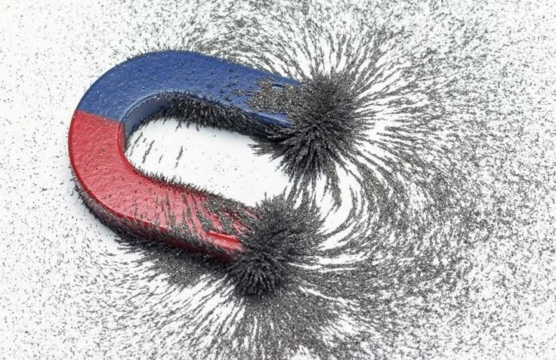

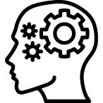

***What's New***

Magnetism is the force exerted by magnets when they attract or repel each other. Magnetism is caused by the motion of electric charges. Every substance is made up of tiny units called atoms. Each atom has electrons, particles that carry electric charges.

Magnetism is a natural force that can pull (attract) or push (repel) objects. Only some materials, called magnetic materials, are affected by magnets. The force of magnetism is strongest near the ends of a magnet, called the poles.



***What's More***

Direction: Use your crayons. Color the faces to show which objects are magnetic and which are not.

|  |  |  |
| --- | --- | --- |
| **OBJECTS** | **MAGNETIC** | **NON MAGNETIC** |
| magnet |  |  |
| books |  |  |
| nails |  |  |
| pencil |  |  |
| building blocks |  |  |

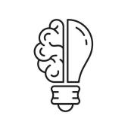

***What I Have Learned***

✔️ Magnetism is a force that can pull or push objects made of certain materials.

✔️ Only some materials, like iron, can be affected by magnets.

✔️ The force of magnetism is strongest at the ends of a magnet, called the poles.

***Assessment***

Direction: Write **T** if the statement is true and **F** if it is false

____1. Magnets can only attract metals like iron and steel.

____2. The force of magnetism is strongest at the poles of a magnet.

____3. A magnet has only one pole, either North or South.

____4. A paperclip can be magnetized by rubbing it with a magnet.

____5. A compass always points toward the South pole of the Earth.

***Additional Activities***

Instructions: Read each statement carefully. If you think the statement is correct, draw a (smiling face). If the statement is incorrect, draw a  (sad face).

_____1. Magnetism is a force that can push or pull certain objects.

_____2. Magnets only work when they are turned on.

_____3. Only metal objects are affected by magnetism.

_____4. Magnetism can work through some materials, like paper or glass.

_____5. The Earth itself acts like a giant magnet.

***What Is It***

Direction: Put a check ( ✔️ ) according to what you feel in each question. I am delighted to receive and know your response!

|  |  |  |
| --- | --- | --- |
|  |  |  |
| 1. Did you enjoy today’s lesson? |  |  |
| 2. Did you understand everything we learned today? |  |  |
| 3. Did you find today’s lesson difficult? |  |  |
| 4. Did you feel proud of your work today? |  |  |
| 5. Are you excited to learn more next time? |  |  |

***What's In***

Magnetism is a force that can pull or push certain objects, especially metals like iron. We see it in everyday things like refrigerator magnets, the motors in toys, and even in speakers that play music!

In the previous lesson, you have learned what is magnetism. In this lesson, you will learn more about magnetism. You will learn about the types of magnets which are the permanent magnets, temporary magnets, and electromagnets.

**It's time for Magnet Hunt!**

Direction: Identify magnetic and non-magnetic objects.

Materials Needed:

● A small bar magnet

● A paperclip

● A plastic spoon

● A coin

● A rubber band

● A small nail

Instructions:

1. Pick up each object using the magnet.

2. If the object is attracted to the magnet, write “Magnetic.”

3. If the object is not attracted to the magnet, write “Non-Magnetic.”

4. What do all the magnetic objects have in common?

***What's New***

What are the Types of Magnets?

• Permanent magnets always have a magnetic field. Example of these are the bar magnets, refrigerator magnets.

• Temporary magnets become magnetic when placed in a magnetic field but lose magnetism afterward. Example of these are the paper clips near a strong magnet and nails.

• Electromagnets are magnets created by electricity passing through a coil of wire wrapped around an iron core. Example of these are in cranes, doorbells, and MRI machines.

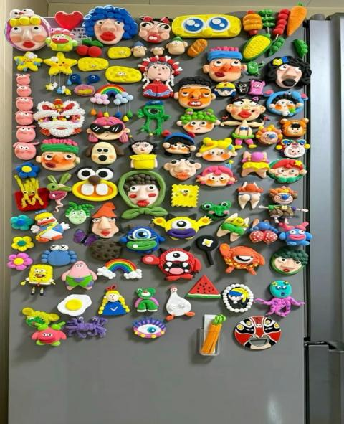

*Figure 2: Example of Permanent Magnets*

<https://pin.it/2AUakfZaM>

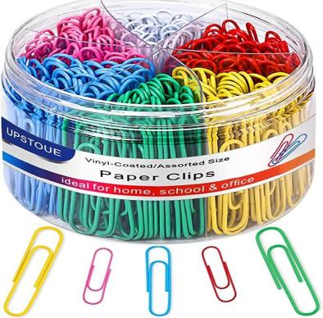

*Figure 3: Example of Temporary Magnets*

<https://pin.it/5GUlMfevV>

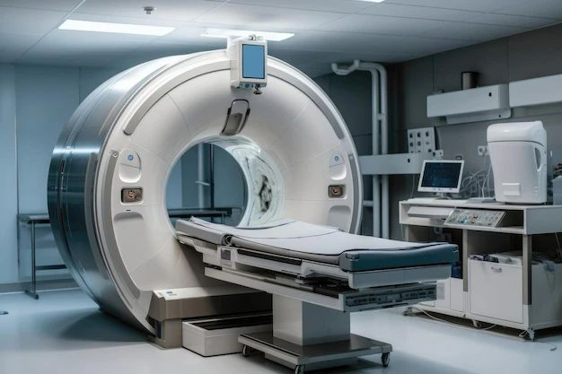

*Figure 4: Example of Electromagnets*

<https://pin.it/fjzNdRwNE>

***What's More***

Direction: Put a heart if the object is a permanent magnet, put a circle if the object is a temporary magnet, and put a star if the object is an electromagnet in the given box.

|  |  |
| --- | --- |
|  |  |
|  |  |

***What I Have Learned***

✔️ Permanent magnets always have a magnetic field, like bar magnets and refrigerator magnets.

✔️ Temporary magnets become magnetic only when near a magnet and lose their magnetism afterward, like paperclips and nails.

✔️ Electromagnets are made by electricity passing through a coil of wire, and can befound in cranes, doorbells, and MRI machines.

***Assessment***

Directions: Match the types of magnets in Column A with their correct descriptions in Column B.

Column A (Types of Magnets) Column B (Description)

1.Permanent Magnet ● A. Loses it’s magnetism easily.

2. Temporary Magnet ● B. Created when electric current flows through a wire.

3. Electromagnet ● C. Always retains its magnetism.

***Additional Activities***

Direction: Read each statement carefully. If you think the statement is correct, draw a (smiling face). If the statement is incorrect, draw a (sad face).

1. All magnets are permanent and never lose their strength.

2. A bar magnet is a type of permanent magnet.

3. An electromagnet needs electricity to work.

4. Horseshoe magnets are stronger than some other types of magnets.

5. Temporary magnets lose their magnetism after some time.

***What Is It***

Direction: Put a check ( ✔️ ) according to what you feel in each question. I am delighted to receive and know your response!

|  |  |  |
| --- | --- | --- |
|  |  |  |
| 1. Did you enjoy today’s lesson? |  |  |
| 2. Did you understand everything we learned today? |  |  |
| 3. Did you find today’s lesson difficult? |  |  |
| 4. Did you feel proud of your work today? |  |  |
| 5. Are you excited to learn more next time? |  |  |

LESSON 3: North and South Pole

***What's In***

Magnets are also used in things like credit cards and MRI machines at the doctor's office. Magnetism helps make many of the devices we use work, from electronics to machines, making it very important in our daily lives.In the previous lesson, you have learned what are the types of magnet. In this lesson, you will learn more about the north and south pole.

**Magnetic Maze Challenge**

Objective: Show how magnets can move objects without direct contact.

Materials: Paper, marker, small metal paper clip, a strong magnet.

Procedure:

1. Draw a simple maze on paper.

2. Place a paper clip at the maze’s starting point.

3. Hold a magnet under the paper and move it to guide the clip through the maze.

4. Challenge students to race or design their own mazes!

Discussion: How does the magnet move the paperclip without touching it?

***What's New***

What is magnetic pole and what are the two poles?

Magnetic pole is a region at each end of a magnet where the external magnetic field is strongest.

The south pole and north pole of a magnet are the two ends of a magnet that have opposite magnetic fields.

• The north pole of a magnet is attracted to the south pole of another magnet.

• The south pole of a magnet is attracted to the north pole of another magnet.

Unlike poles of different magnets attract each other; like poles repel each other.

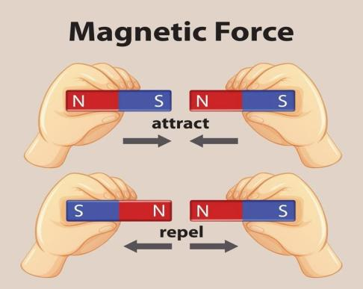

*Figure 3: North and South Pole*

<https://pin.it/3rhYKUwZx>

***What's More***

Directions: Write the word **"NORTH"** if the statement is correct and **"SOUTH"** if it is incorrect.

1. A magnet has only one pole.

2. Opposite poles of a magnet attract each other.

3. Like poles of a magnet repel each other.

4. The Earth’s geographic North Pole is the same as its magnetic north pole.

5. If you break a magnet in half, each piece will still have a north and south pole.

***What I Have Learned***

✔️ Magnets attract some materials, like iron and steel, but not others, like wood or plastic.

✔️ Magnets have two poles, a north and a south pole, and opposite poles attract while the same poles repel.

✔️ Magnets can move objects without touching them, and they have invisible magnetic fields.

✔️ Some magnets are stronger than others, and they are used in everyday life, like in compasses, refrigerators, and electronics.

***Assessment***

Direction: Determine if the given picture indicates repel and attract. write repel if it repels and attract if it attracts.

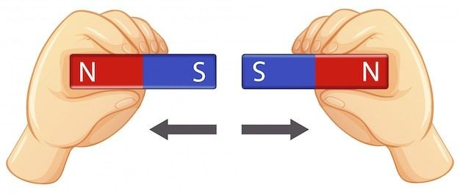1.

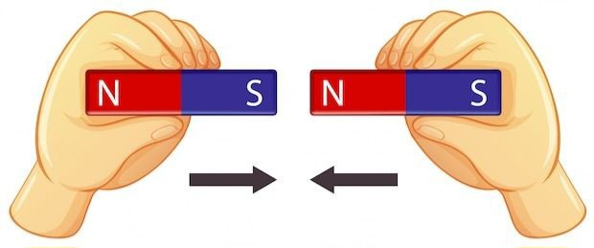2.

3. 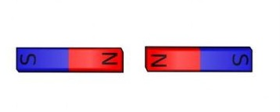

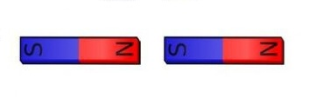4.

***Additional Activities***

Instructions: Read each statement carefully. If you think the statement is correct, draw a (smiling face). If the statement is incorrect, draw a  (sad face).

1. Every magnet has two poles: a north pole and a south pole.

2. If you bring two north poles of a magnet together, they will attract.

3. The magnetic force is strongest at the poles of a magnet.

4.The north pole of a magnet will always point toward Earth's north when freely hanging.

5. If you break a magnet in half, each piece will still have a north and south pole.

***What Is It***

Direction: Put a check ( ✔️ ) according to what you feel in each question. I am delighted to receive and know your response!

|  |  |  |
| --- | --- | --- |
|  |  |  |
| 1. Did you enjoy today’s lesson? |  |  |
| 2. Did you understand everything we learned today? |  |  |
| 3. Did you find today’s lesson difficult? |  |  |
| 4. Did you feel proud of your work today? |  |  |
| 5. Are you excited to learn more next time? |  |  |

***LESSON 4: EVERYDAY USE OF MAGNETISM***

***What's In***

In the previous lesson, you have learned the north and south pole. In this lesson, you will learn more about magnetism. You will learn about the everyday uses of magnetism. Magnets are in many things we use everyday. They are all around us and sometimes we can't even see them. This lesson describes some common uses of magnets.

**Magnetic Treasure Hunt**

Objective: Students will investigate objects in the classroom to find hidden magnetic materials.

Materials:

● Small hand-held magnets

● Classroom objects (staplers, chairs, whiteboards, paper, pencils, rulers, etc.)

● A recording sheet to note findings

Procedure:

1. Give each student a magnet.

2. Have them walk around the classroom and test different objects.

3. Record which objects are magnetic and which are not.

4. Discuss the findings as a class.

Extension: Ask students to predict whether an object will be magnetic before testing it.

***What's New***

Magnets play a vital role in modern life, appearing in countless everyday items and technologies. From the simple fridge magnets that hold up photos to the powerful magnets inside medical imaging machines, their uses are diverse and indispensable. Let’s explore where magnets are found and how they impact our lives.

● Refrigerator Magnets: Used to hold notes, photos, and reminders on refrigerators or other metal surfaces.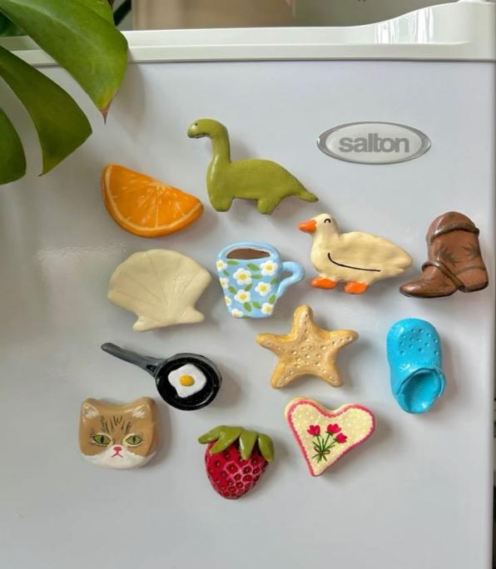

*Figure 4: Refrigerator Magnets*

*https://pin.it/6j3Xg5uls*

● Credit Cards & IDs: Many credit cards and identification cards contain magnetic strips for data storage.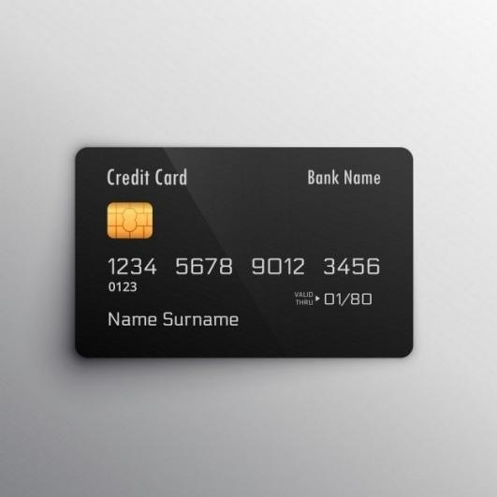

*Figure 5: Credit Card*

*https://pin.it/7k0AdKqeO*

● Electric Motors: Magnets are integral to the operation of electric motors, found in appliances like fans, blenders, and vacuum cleaners.

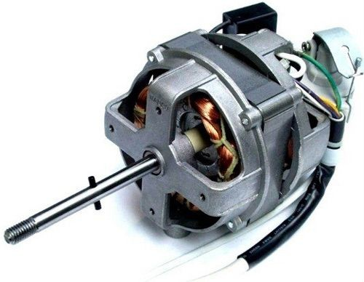

*Figure 6: Electric Motors*

*https://pin.it/4OlFoHwWv*

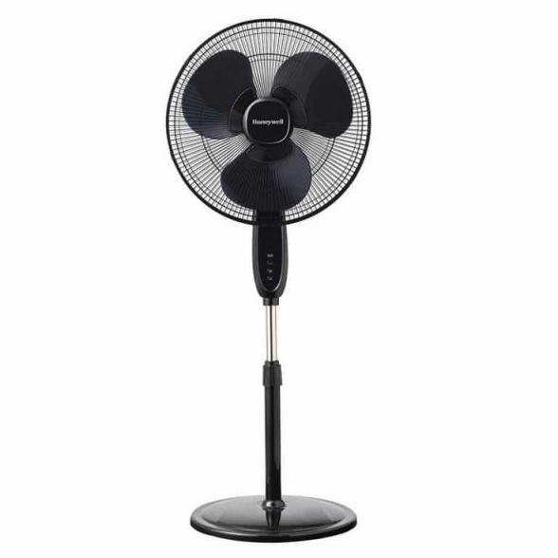

*Figure 7: Fan*

*https://pin.it/219Z6KeiZ*

● Toys: Many toys use magnets, such as magnetic building blocks or dolls with magnetic accessories.

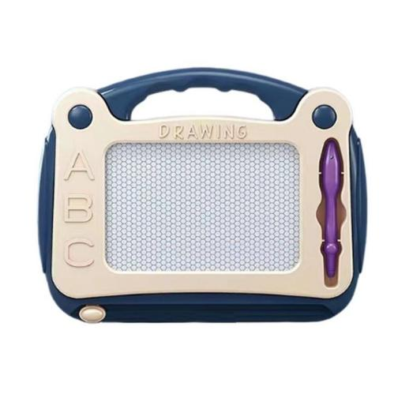

*Figure 8: Toy (boy)*

*https://pin.it/1HPsnefpb*

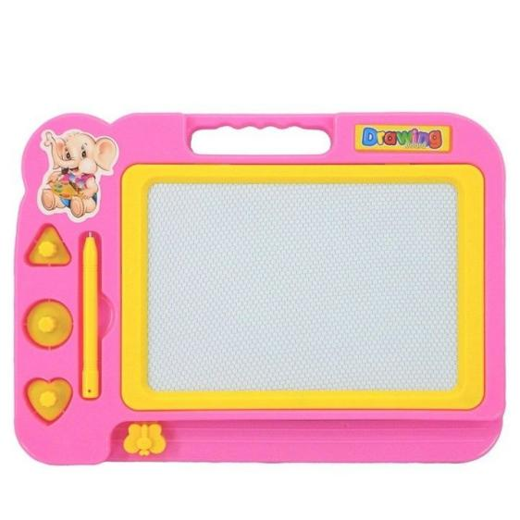

*Figure 9: Toy (girl)*

*https://pin.it/2XXxupuXg*

***What's More***

Direction: Write a big check ✔️ to the picture if these things you see in your house is magnetic.

|  |  |
| --- | --- |
|  |  |
|  |  |
|  |  |
|  |  |

***What I Have Learned***

✔️ Magnets in Household Items: Magnets are used in everyday objects like refrigerator magnets, which hold notes and photos, and in electric motors that power appliances like fans and vacuum cleaners.

✔️ Magnets in Technology: Many credit cards and identification cards use magnetic strips to store data, showing how magnets are important in modern financial and security systems.

✔️ Magnets in Toys: Magnets are also found in toys, such as magnetic building blocks or dolls with magnetic accessories, helping children learn and play in creative ways.

***Assessment***

List down and include pictures of the things around your house that are has magnets and explain why and how is it useful.

***Additional Activities***

Instructions: Read each statement carefully. If you think the statement is correct, draw a (smiling face). If the statement is incorrect, draw a  (sad face).

1. Magnets are used in MRI machines in hospitals.

2. Compasses use magnets to help people find direction.

3.Magnets are found inside some types of speakers and microphones.

4.Magnets can be used to pick up plastic objects.

5. Some trains use magnets to float above the tracks and move faster.

***What Is It***

Direction: Put a check ( ✔️ ) according to what you feel in each question. I am delighted to receive and know your response!

|  |  |  |
| --- | --- | --- |
|  |  |  |
| 1. Did you enjoy today’s lesson? |  |  |
| 2. Did you understand everything we learned today? |  |  |
| 3. Did you find today’s lesson difficult? |  |  |
| 4. Did you feel proud of your work today? |  |  |
| 5. Are you excited to learn more next time? |  |  |

***What I Can Do (Post Test)***

Directions: Choose the letter of the best answer. Write the chosen letter on a separate sheet of paper

1. What causes magnetism?

a) The motion of electric charges in atoms

b) The heat of the sun

c) The weight of an object

d) The presence of water

2. What is the strongest part of a magnet called?

a) The middle

b) The sides

c) The poles

d) The handle

3. Which type of magnet needs electricity to work?

a) Permanent magnet

b) Temporary magnet

c) Electromagnet

d) None of the above

4. If you put a north pole of a magnet near a south pole of another magnet, what will happen?

a) They will attract

b) They will repel

c) They will melt

d) They will disappear

5. What type of magnet is a refrigerator magnet?

a) Temporary magnet

b) Electromagnet

c) Permanent magnet

d) None of the above